1.Account table in DB before funds transfer

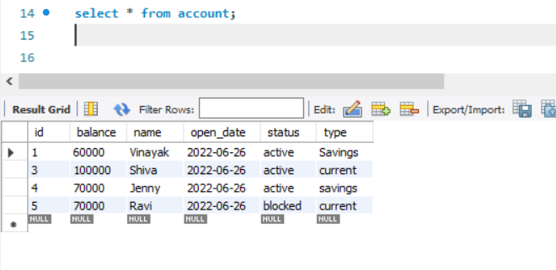

2.Transfer funds

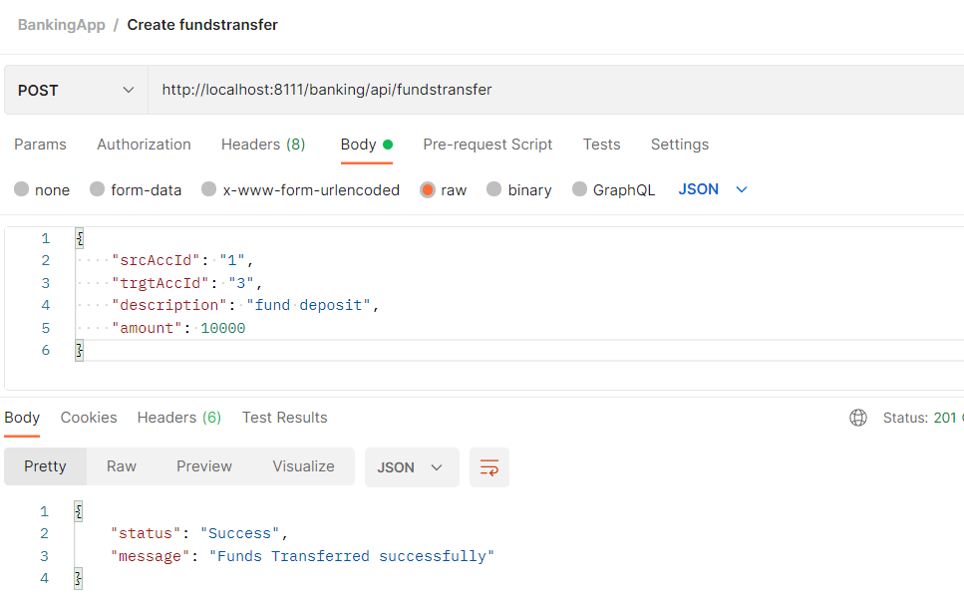

3. Account table in DB after fundstransfer

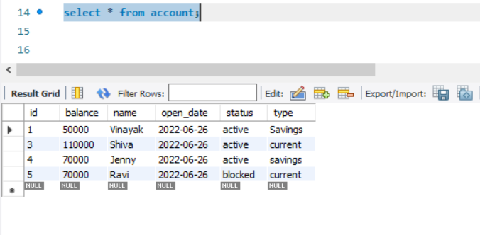

4. Transaction table in DB after fundstransfer

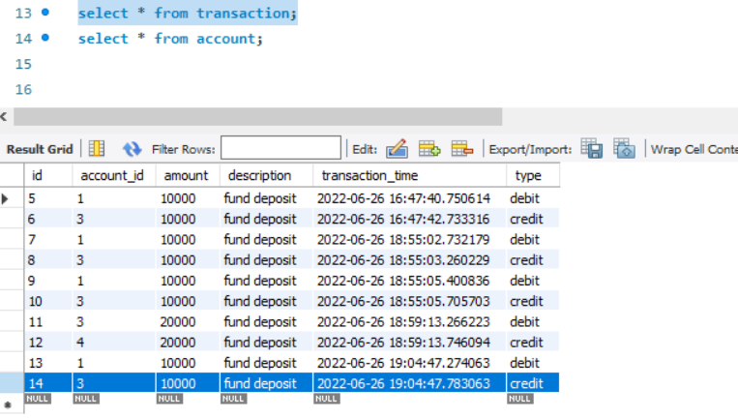

5. Account table in DB before fundstransfer roll back

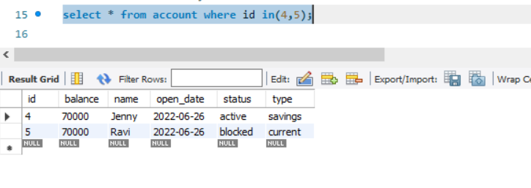

6. Transfer funds for rollback sample from active account to blocked account

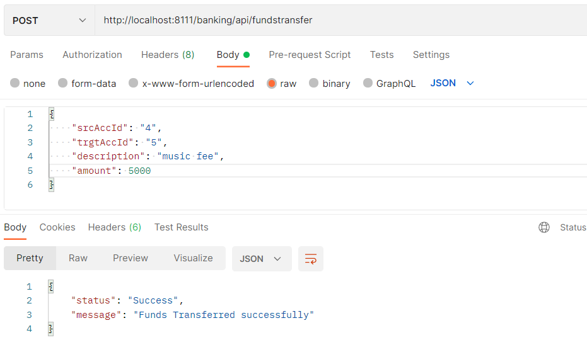

7. Transaction table in DB after rollback sample

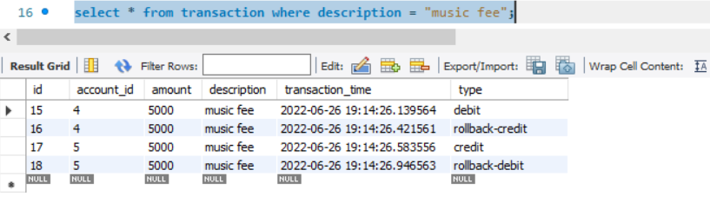

8. Account table in DB after rollback sample

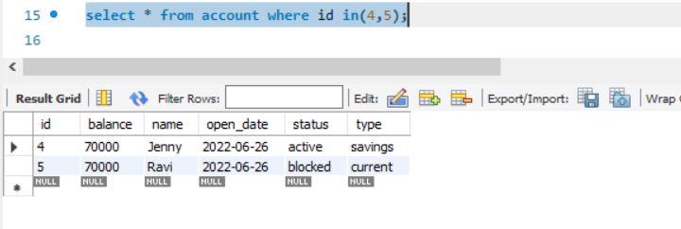

9. Validations

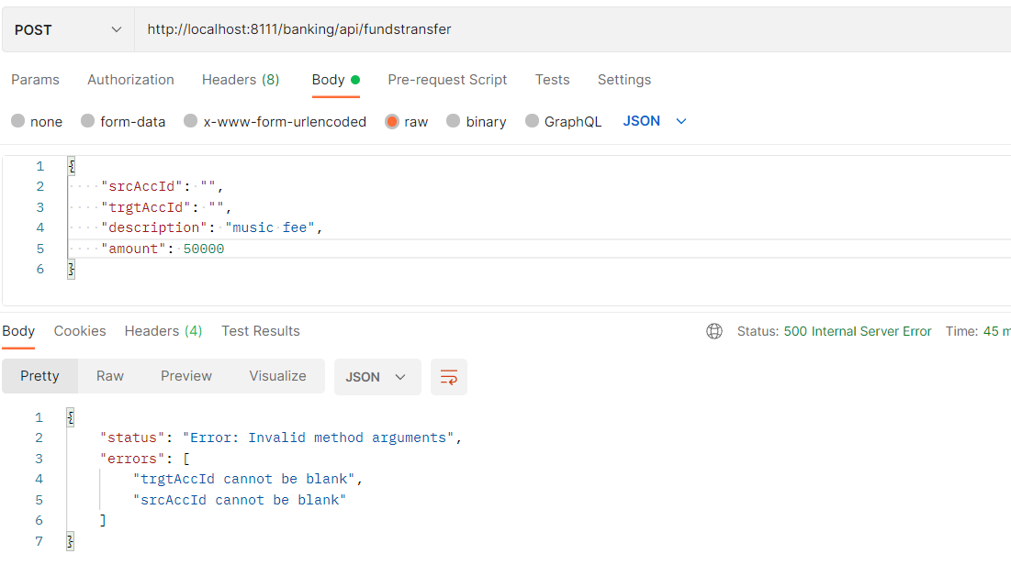

10. Exception handling

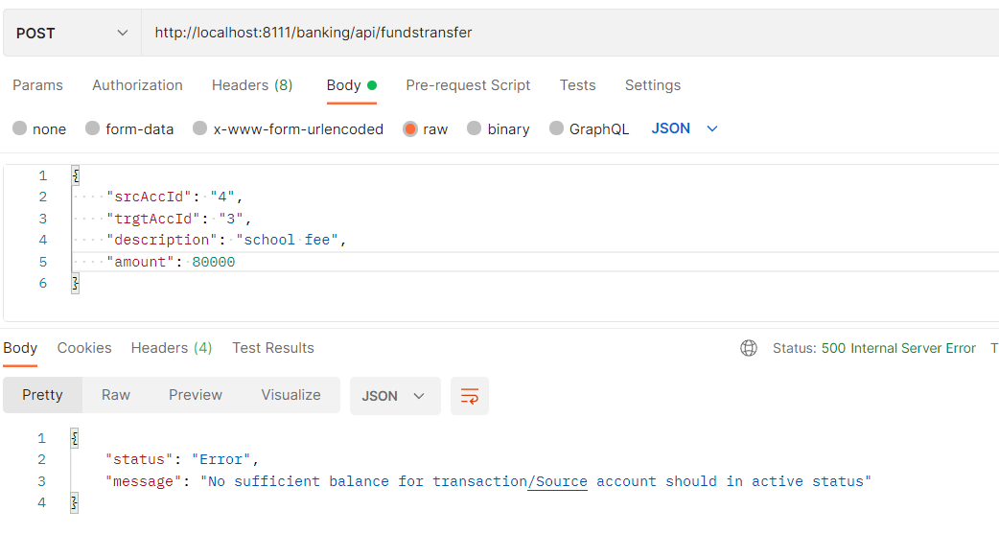

11. Junit – Controller tests

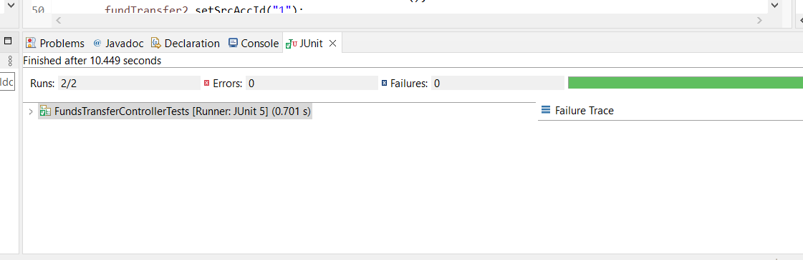

12. Service tests

